**CHAPTER-1**

**INTRODUCTION**

**1.1.1 Project Title:**

**“Turn the Page”**

**1.1.2 Project Category:**

### Web Application

#### 1.1.3 Overview

In this era of highly advanced software, one can observe a lot of progress in the zone of architectural design and its principles. There are various innovative and efficient software emerging out in the market which have made the life of a common man very simple and easy. Our Online Bookstore is one such software. It is a combination of both e-commerce and book sales industry put together in a single software. Using the online bookstore system has a lot many benefits. There is absolutely no necessity for a consumer to go out looking for a particular book. The book of his/her liking can be easily purchased using the online bookstore software sitting in their comfort zone and just running the software on a system with an active internet connection and a web browser. This helps in saving a whole lot of time and energy of the consumer. Our project is designed and implement using HTML and PHP languages. The database is managed using MySQL and the client-server communication is handled by XAMPP.

## Scope of the system

In this application the users can view many books of different category. Users who get registered to this web site can get information about the Books to which they want to purchase for. The users can get the information about the all the stock varities of Books at a single place. Thus prevents the users to visit book stores. Once the User get registered, they can view different shops that has been registered to the website. So that User can view the different books as well as compare price of the books.

Admin has access in all the part of the website . He has privilege to manage users and shopkeepers. Admin has control to display and manage shopkeepers and users of the application. The shopkeeper who wants to register in this website should pay monthly fee In order to get add books to the application. As there will be completion in publicity regarding selling the books to the users.

## 1.5 Modules used

Our Proposed system has three main modules:

* Admin
* Shopkeeper
* User

### 1.5.1 Module description

**Admin**: Admin should have complete knowledge of the website. Admin has the following control over the website.

* Login
* Shopkeeper management
* User management
* Logout

**Shopkeeper**: In this project Multiple shopkeepers make use of the website. Each shopkeeper has the following control over the website.

* Shopkeeper Registration
* Login
* View Registered users
* Add books
* Update books
* View order details
* View requested books
* View feedback
* Logout

**User** : The user can use application to order books. user has the following control over the website.

* Registration
* Login
* Search books
* View books
* Request book
* Add to cart
* Order books
* Give feedback
* Logout

**CHAPTER- 2**

**REQUIREMENT ANALYSIS**

**2.1 EXISTING AND PROPOSED SYSTEM**

**2.1.1 EXISTING SYSTEM**

Things going manuallylike going to Bookshop and checking the books and buying the books. No security for database because all the books information is kept in records and that work is also done by man using man power so there is chance of doing mistakes.

Drawbacks:

* This process is so much time-consuming and does not provide trust in retailers.
* There is the threat of forgery if you are new to marketing and do not know how to bargain with these street sellers.
* There is no proper way of getting to know about the actual price of the books sometimes shopkeepers sell it more than the market price by saying that the book is not available in the market.
* It might be the case that shopkeepers do not refund money if you purchase some wrong books.

**2.1.2 PROPOSED SYSTEM**

In this application the users can view many books of different category. Users who get registered to this web site can get information about the Books to which they want to purchase for. The users can get the information about the all the stock varieties of Books at a single place. Thus prevents the users to visit book stores. Once the User get registered, they can view different shops that has been registered to the website. So that User can view the different books as well as compare price of the books. Admin has access in all the part of the website .He has privilege to manage users and shopkeepers. Admin has control to display and manage shopkeepers and users of the application. The shopkeeper who wants to register in this website should pay monthly fee. In order to get add books to the application. As there will be completion in publicity regarding selling the books to the users.

**2.2 TOOLS AND TECHNOLOGIES USED**

**2.2.1 VISUAL STUDIO**

Microsoft Visual Studio is an IDE made by Microsoft and used for different types of software development such as computer programs, websites, web apps, web services, and mobile apps. It contains completion tools, compilers, and other features to facilitate the software development process.

**2.3 HARDWARE AND SOFTWARE REQUIREMENTS**

* + 1. **SOFTWARE REQUIREMENTS:**
* Operating System : Windows 10/Linux.
* Front End : CSS, Java Script.
* Back End : PHP.
* Database : MySQL.
* Tools : Visual Studio, Google chrome/Mozilla Firefox.

**2.3.2 HARDWARE REQUIREMENTS:**

* Processor : i3 and above.
* RAM : 4 GB.
* Hard disk : 500 MB available internal storage.

**CHAPTER- 3**

**SOFTWARE REQUIREMENTS SPECIFICATION**

**3.1 INTRODUCTION**

SRS totally characterizes the entire venture and the product and how it will be relied upon to performed. A Software Requirement Specification is a whole elaboration of the real constancy and climate for programming under measure. To characterize the customer necessities, designer should have the flawless and clear data about item which must be built. It is the fundamental stage for the set up.

Attributes of SRS:

* Understanding the necessities
* Verification is finished
* Unambiguous
* Consistent is kept up
* Fully Complete

**3.2 FUNCTIONAL REQUIREMENTS**

Proposed system has three main modules:

* **User**
* **Shopkeeper**
* **Admin**

**3.2.1 User Module**: User will use the system to search and order book.

* Login Module: This module is used to login into the system .
* Registration module: This module is used to register a new user to the system. System is to be provided with basic information of user during registration.
* Search Module: User uses this module to search a book based on book title or author.
* View Book Module: This module is used to present all available books to user with well defined interfaces.
* Add to cart: This module is used to add book to the cart.
* Order module: This module is used to order a book from the store.
* Payment Module: This module is used to do payment once he order a book from the store.
* Feedback Module: This module is used by the user to write feedback about purchased book.

**3.2.2 Shopkeeper Module:** Shopkeeper will use the System to add, update and delete books also to view the details of the user and orders made by users.

* Login Module: This module is used to login into the system.
* Registration module: This module is used to register a new shopkeeper to the system.

System is to be provided with basic information of user during registration

* Add Book Module: This allows shopkeeper to add a new book to the system.
* View/Update Module: Shopkeeper uses this module to view and update book information.
* View Order: This module is used by the shopkeeper to view ordered slot and buyer information.
* View Feedback Module: This module is used by the shopkeeper to view user feedback.

**3.2.3 Admin Module:** Admin will manage shopkeeper and user information.

* Login module: This module is used to login into the system.
* Shopkeeper module: This module is used to manage all shopkeepers of the system.
* User module: This module is used to manage all users of the system.

**3.3 NON-FUNCTIONAL REQUIREMENTS**

* Maintainability: Maintenance is easy and economical.
* Portability: This system can be run in any operating system and browser.
* Usability: Software should be usable, without any effort and it should have appropriate user interface.

CHAPTER-4

ANALISIS AND DESIGN

DFD: ADMIN

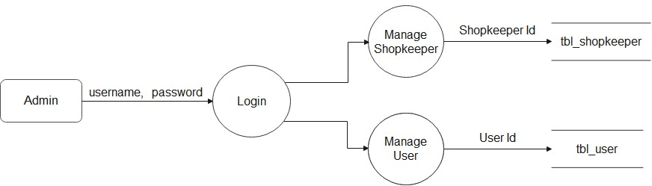

*Data Flow Diagram level 2 for Admin*

DFD: SHOPKEEPER

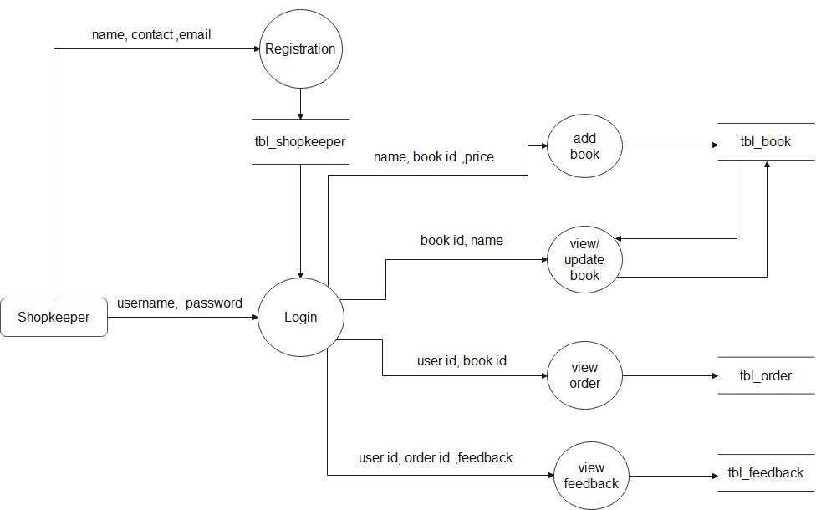

*Data Flow Diagram level 2 for Shopkeeper*

**DFD : User**

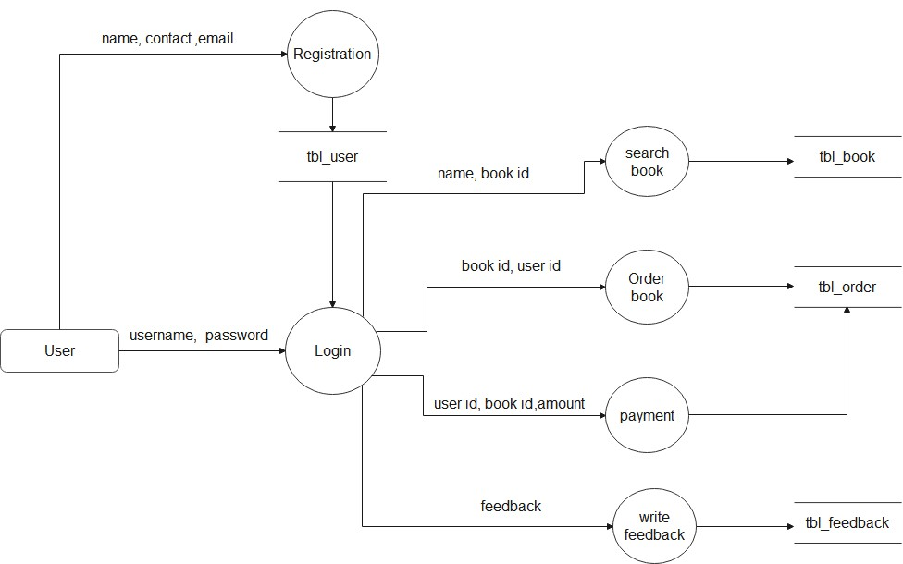

***Figure: 3.4.2.6 Data Flow Diagram level 2 for User***

**ER-DIAGRAM**

